**REWARDS SYSTEM**

User Stories:

As Jessica, I would like to accumulate 50,000,000 points by the end of this lockdown. So, I can buy the new shoes for post lockdown.

As Jimmy, I would like to achieve my set goal of 15,000 steps by the end of the day. So, I could get the 15 points.

As Catherine, I would like to have a look around all the options in the store. So, I can make a good purchase.

Mockups:

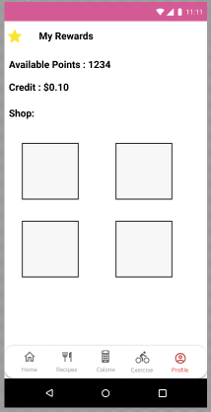 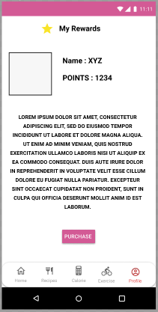

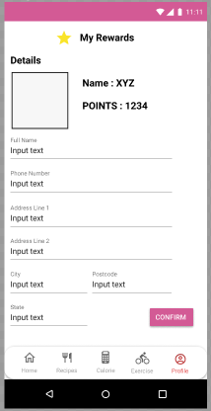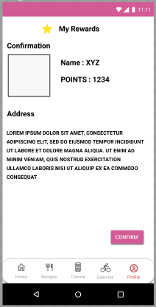 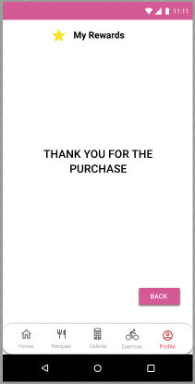

Textual Explanation:

This feature of our application will work by letting the user make purchases using all the points they have earned from finishing their goals/tasks. Once the user accumulates a certain number of points to purchase a product they then can go to the rewards section and click on “My Rewards”. Then they can scroll through all the available products until they find what they want and can select the product. Once they click on confirm they can continue onto reading the description of the product. They can then choose to receive it or send it to someone else on their behalf.

Design Diagrams

Validation Criteria

To confirm that this is a successful implementation of the Rewards System feature the validation criteria is as follows:

1. Successfully list all the products available in the store
2. Once a product is selected it, the description should be clear
3. The Phone number field should be valid
4. The State field should be valid
5. The confirm buttons should work (It should take them to the next page)
6. If the Back button is pressed it should take the user back to the main page

These testing results should confirm that the rewards section meet the above testing criteria, otherwise it should be redone until it satisfies the requirements.

**EXERCISE GEOLOCATION**

User Stories:

As Jimmy, I would like to find my friends who are also exercising near my house. So, I can have fun while also staying fit.

As Catherine, I would like to plan a route from my house to the nearest shopping market. So, I can get my step count for the day.

As Jessica, I would like to save locations on my app that I visit frequently on foot. So, the next time I plan to visit one of those locations I can do it in once click.

Mockups:

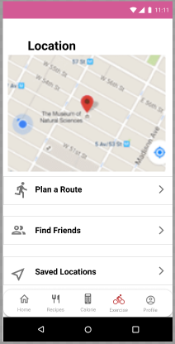

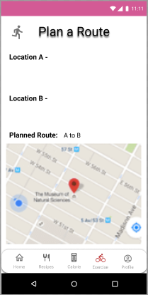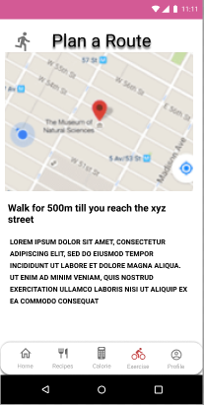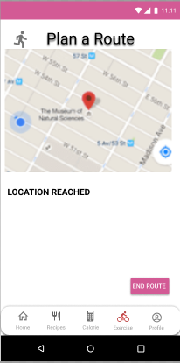

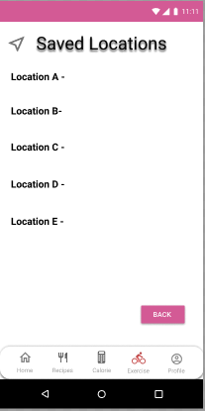

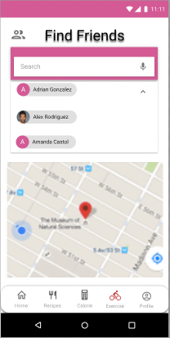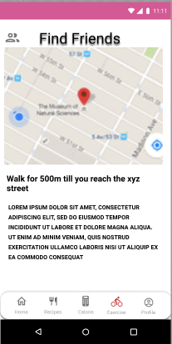

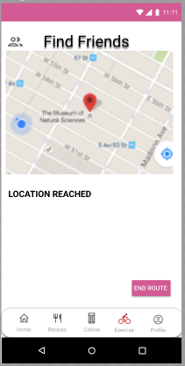

Textual Explanation

This feature of the application lets the user find the best route to take a walk or jog to their preferred destination, find friends, save frequently visited locations. If they choose to plan a route they have to enter the start location and the end location and then they will get a message to confirm the location. Once confirmed it will create a route and show them detailed steps to the location. Once they reach the location they can end it by clicking on the end button. If they choose the find friends features they can search for a friend and select them and then they can get their location. Then the user can choose either to go back or they can create a route to their mate by clicking on create route button. If they choose the saved locations feature, they can add frequently visited locations (so they can create a route to that particular location in once click).

Design Diagram

Plan a Route:

Saved Locations:

Validation Criteria

To confirm that this is a successful implementation of the Exercise Geolocation feature the validation criteria is as follows:

1. It should successfully save locations
2. It should show all the users friends’ location nearby
3. It should successfully map out a walking route to the end location
4. It should show the user detailed steps to a location.
5. It should successfully end the route when clicked on the end route button.

These testing results should confirm that the Exercise and Geolocation feature meet the above testing criteria, otherwise it should be redone until it satisfies the requirements.

**GRAPHS AND STATISTICS**

User Stories:

As Catherine, I would like to know how many calories I have burned on average in the past week. So, I can either makes changes to my lifestyle or ease up a bit.

As Jessica, I would like to know how many calories I have consumed on average in the past week, So, I can make some changes to my diet.

As Jimmy, I would like to know how many steps I have taken on average in the past week. So, I can compare it with my mates.

Mockups

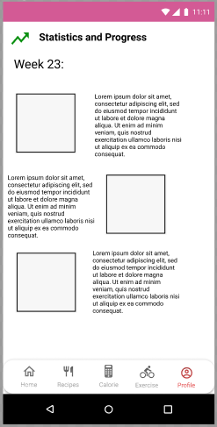 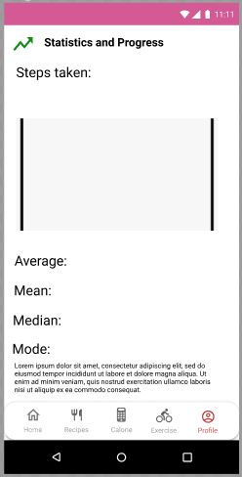

Textual Explanation

This feature of the application lets the user track their goal progress. It allows the user to get a snapshot of how their week has been, this gives them different statistics such as number of steps taken each day, or an average number of steps taken each week. It also allows user to track their caloric intake to further allow them to make changes. This feature allows gives a statistic on what days of the week the user has been mostly active or on what days the user fails to achieve their goals.

Validation Criteria

To confirm that this is a successful implementation of the Graphs and Statistics feature the validation criteria is as follows:

1. It should successfully display all the graphs and statistics according to the weeks
2. It should give a clear explanation of the statistics.
3. It should let the user share the statistics to their mates using one of the listed social media accounts.
4. It should allow the user to compare the statistics with their mates
5. It should successfully display the steps, calories consumed, calories burned etc.

These testing results should confirm that the Graphs and Statistics feature meet the above testing criteria, otherwise it should be redone until it satisfies the requirements.